**ISDS-415**

**BUSINESS INTELLIGENCE**

A close up of a logo

Description generated with very high confidence

**Submitted By:**

**Vaishali Patel**

Coffee Chain was operating with a good amount of profit in various locations. When exploring the data, I observed is there are several locations where the chain is going through a huge loss and unable to get rid of inventory. This may be caused due to lack of marketing or more expenses for the less popular products.

Let’s take a look at overall data with all the variables available for analysis.

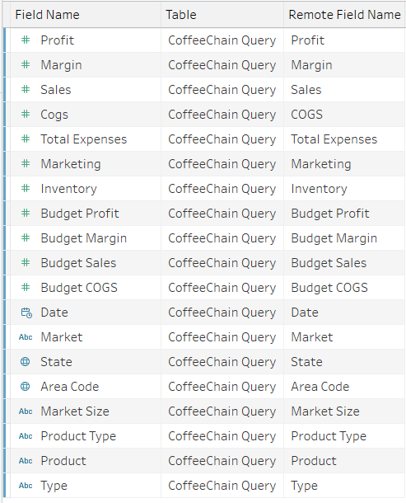

Let’s take a look at overall picture of Coffee supply which represents the profit of various products for different locations. To take a detail look into this, I have created a hierarchy for products and it types. The bigger than bubble is more the profit gained.

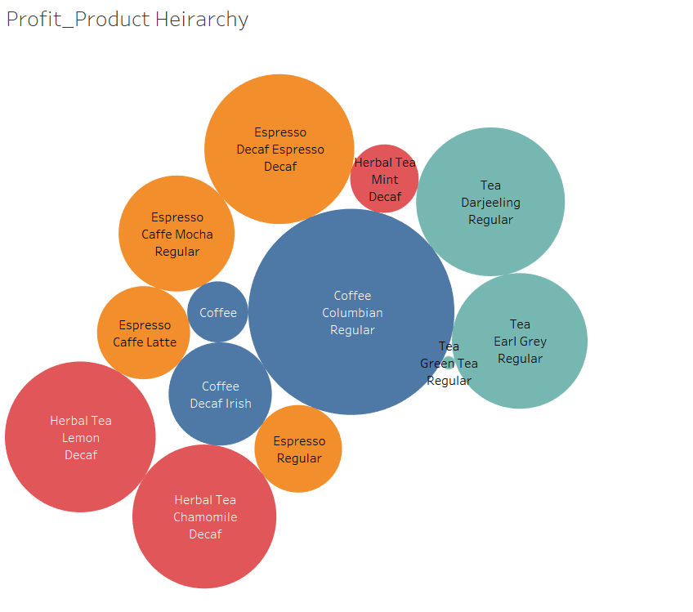

For the above chart, we can figure out that there are some issues happening for Tea, and the type is Green Tea Regular. The profit for this product is -238 which means Green Tea Regular leads to loss. There are other products as well which has some less profit compared to highest sold products example Coffee followed by Herbal Tea Mint Decaf.

Let’s dive deep into the analysis by each product and its type for profit. We can see from the below chart that each product has one category which contributes to negative revenue. The product types are Amaretto, Decaf Irish Cream under Coffee; Caffe Mocha under Espresso; Mint under Herbal Tea; Green Tea under Tea.

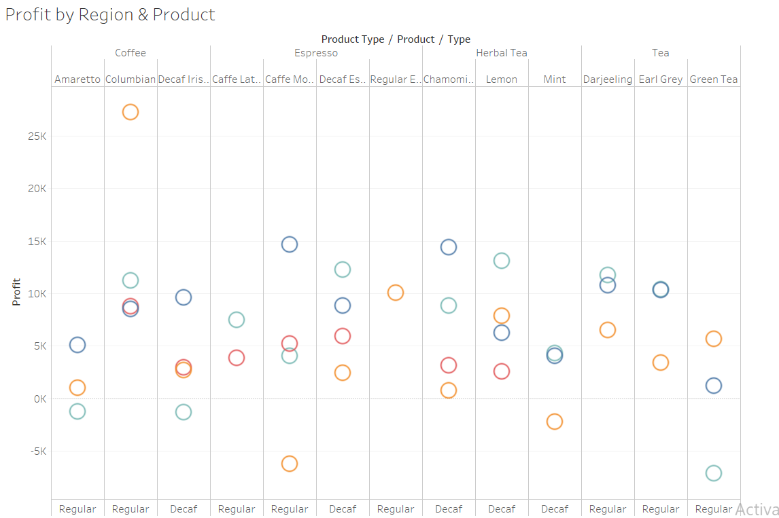

To evaluate this, I started looking to the expenses, that which state has overhead expenses. From below map we can see California, Nevada and New York has the highest expenses.

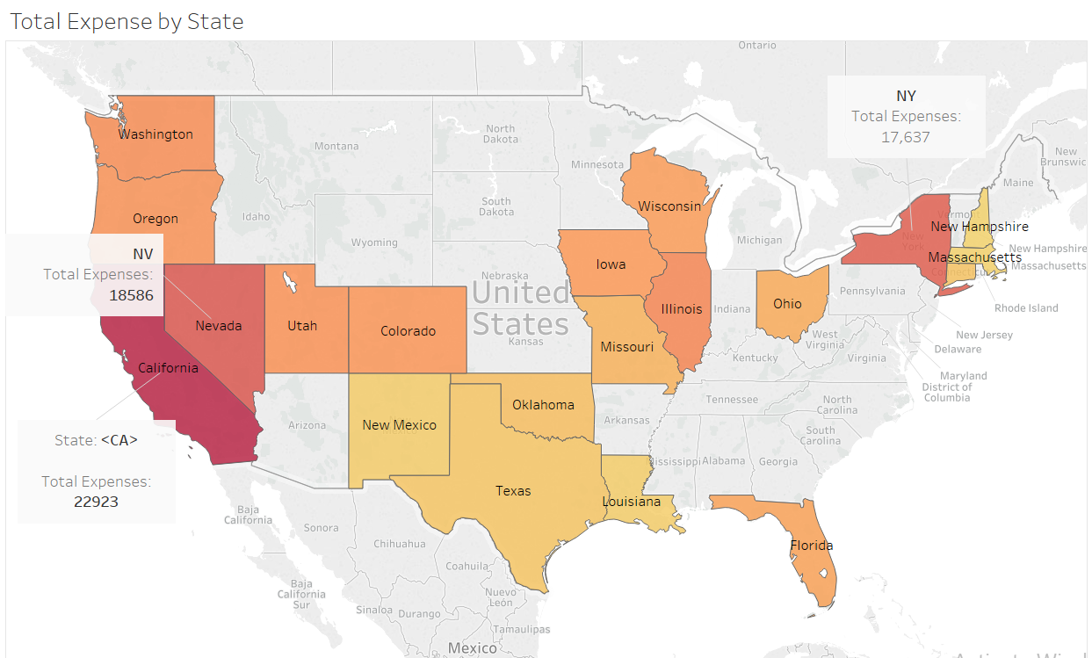

The below table indicates in which state the profit is less by this we can identity the contribution of each product. We can depict that the total expense of New Mexico is 10% more than the profit, followed by Utah, Wisconsin, Missouri and New Hampshire.

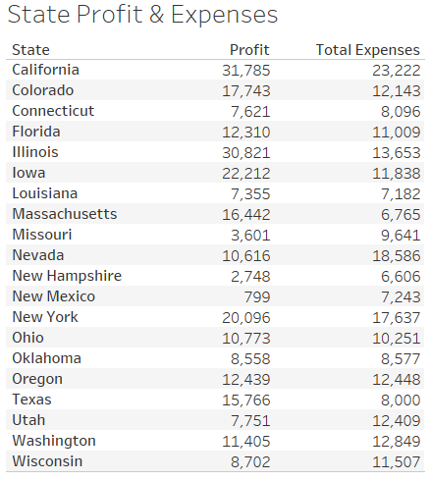

The below graph represents the yearly sales of each product and its types. Herbal tea, Tea and Espresso products are less sold.

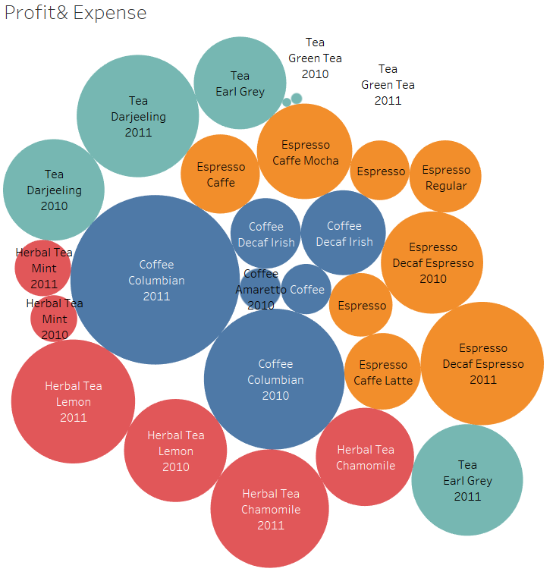

There are some product types which are less sold, has huge inventory at the same time these products have expense amount much greater than profit. Marketing cost is getting more, but still has no effects on sale. Basically, these are the products which are disliked by the consumers.

There is some other evidence about the less selling products.

